TUTORIAL DISCUSSION (1)

1. It is claimed that no significant SQA activities are expected to take place during the

phase of production planning for software products.

a) Discuss this claim

b) Compare the required production planning for a new automobile model with the

production planning efforts required for the new release of a software product  
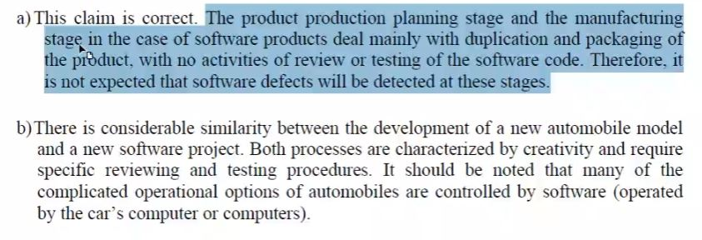  
**Product planning is the ongoing process of identifying and articulating market requirements that define a product’s feature set.**

2. Referring to the seven environmental characteristics of software development and

maintenance, consider the characteristics of future software products, discussing

whether the professional and managerial burden of coping with these characteristics in

 future is expected to be higher or lower when compared with the current

performance of these activities. 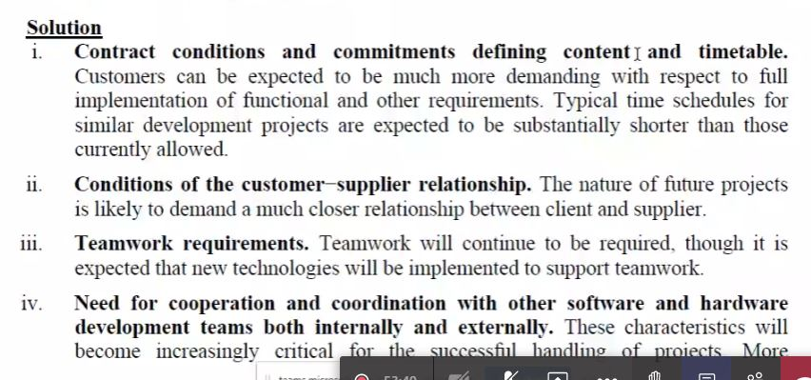

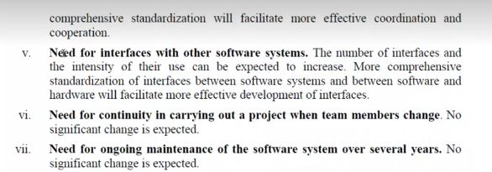3.Compare and contrast of Corrective Action and Preventive Action. Provide THREE (3)

IT-related examples for EACH category the action plan.

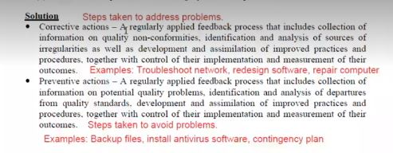

4. The need to carry out work by a team demands additional investment in coordination

of the team members. Discuss whether these managerial efforts could be saved if the

work were performed as a “one-man job”. 